Euclid's Theorems in Right Triangles

Definition
# Source: AI Source: Provided by: [Data Path: Persons Table -> ID Column: 1, Name_En Column: Motasem Essam] -> From: [ChatGPT] on [7/25/2026]
Euclid's Theorems in Right Triangles are two important geometric relationships that connect the altitude, hypotenuse, and legs of a right triangle.
They are derived from the similarity of the smaller triangles created when an altitude is drawn from the right-angle vertex to the hypotenuse.
Consider right triangle $ABC$, where:
$$∠C={90}^{∘}$$
and altitude $CD$ is drawn perpendicular to hypotenuse $AB$.
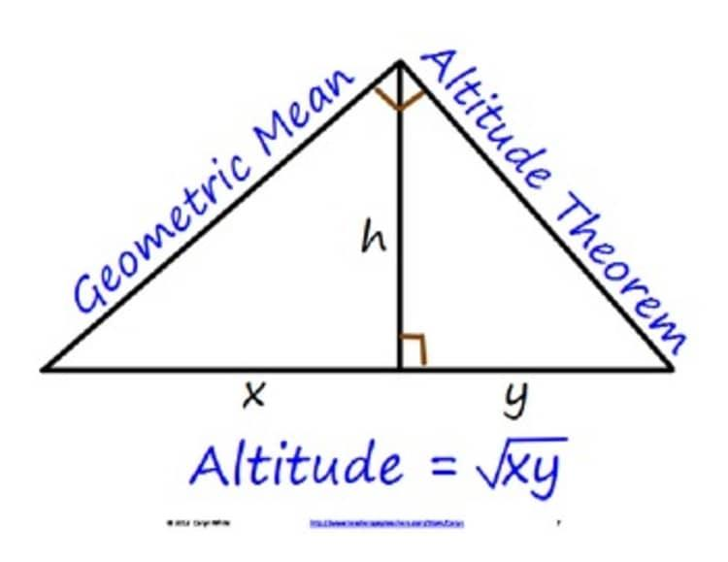
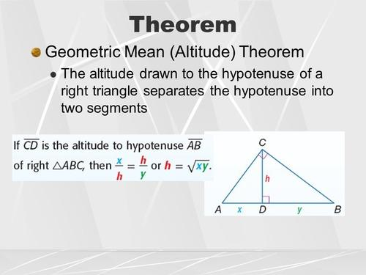
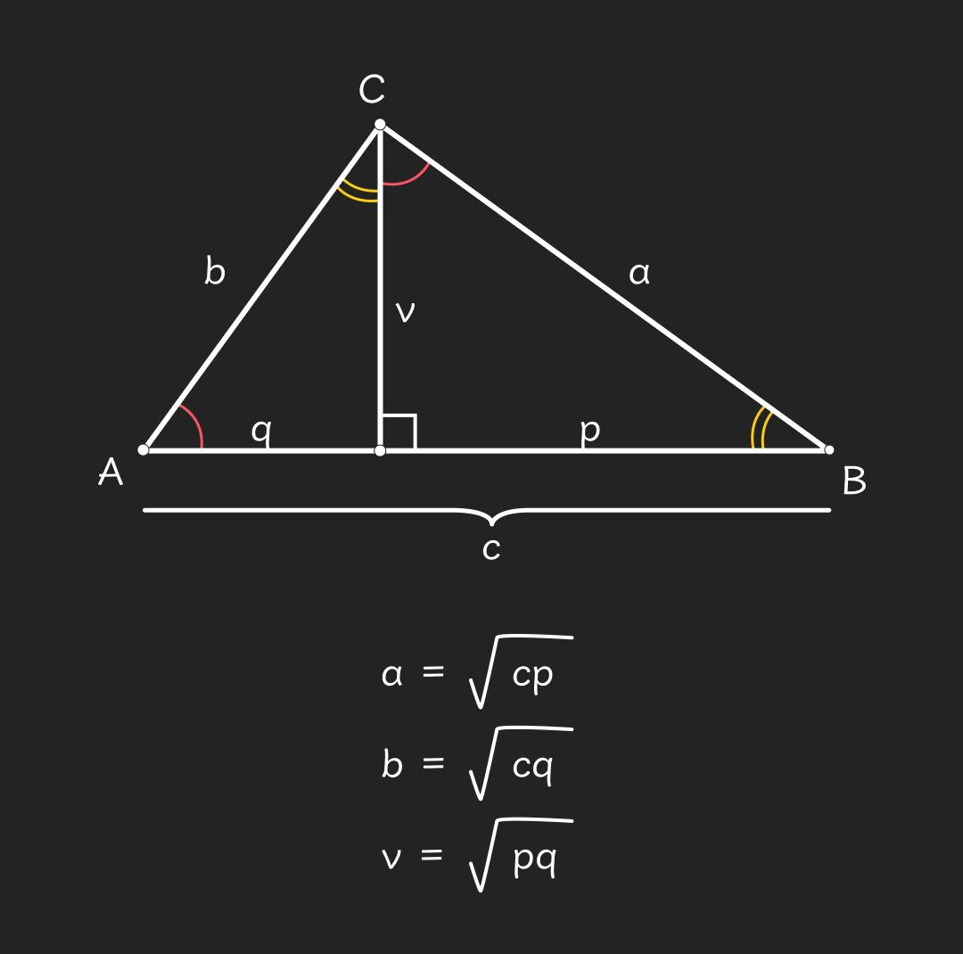
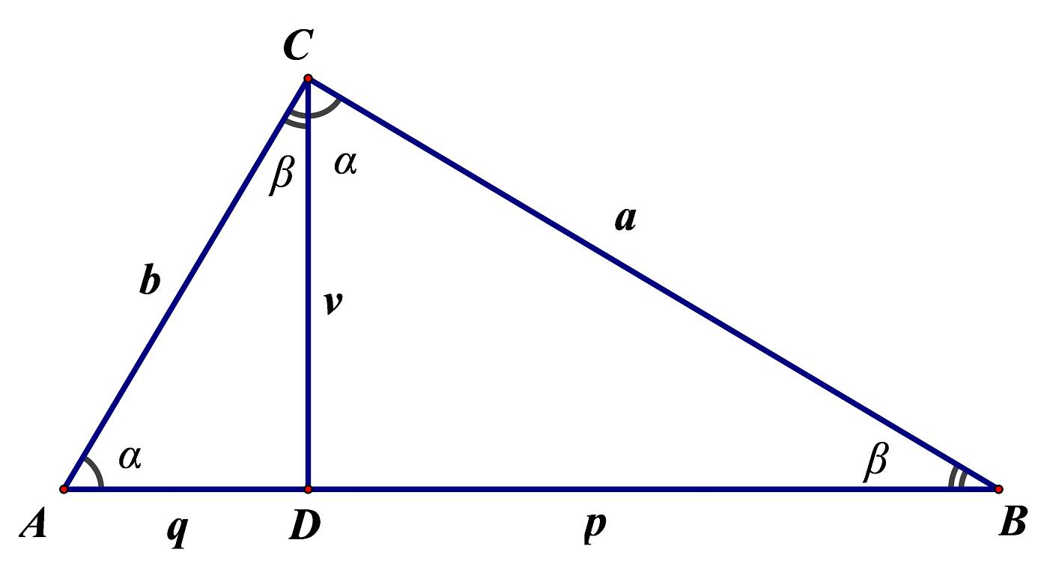

Purpose
# Source: AI Source: Provided by: [Data Path: Persons Table -> ID Column: 1, Name_En Column: Motasem Essam] -> From: [ChatGPT] on [7/25/2026]
Euclid's Theorems are used to:
- Calculate unknown lengths in right triangles.
- Relate the altitude to the two parts of the hypotenuse.
- Relate each leg to the hypotenuse and its adjacent hypotenuse segment.
- Solve geometric problems using proportional relationships.
- Establish relationships between similar triangles.
- Provide an alternative approach to some Pythagorean Theorem problems.

Basic Configuration
# Source: AI Source: Provided by: [Data Path: Persons Table -> ID Column: 1, Name_En Column: Motasem Essam] -> From: [ChatGPT] on [7/25/2026]
Consider right triangle $ABC$:
$$∠C={90}^{∘}$$
Draw an altitude from $C$ to hypotenuse $AB$.
Let the altitude meet $AB$ at $D$:
$$CD⊥AB$$
The hypotenuse is divided into two segments:
$$AD=p \\ DB=q$$
and the altitude is:
$$CD=h$$
The original hypotenuse is:
$$AB=c$$
Therefore:
$$\boxed{c=p+q}$$
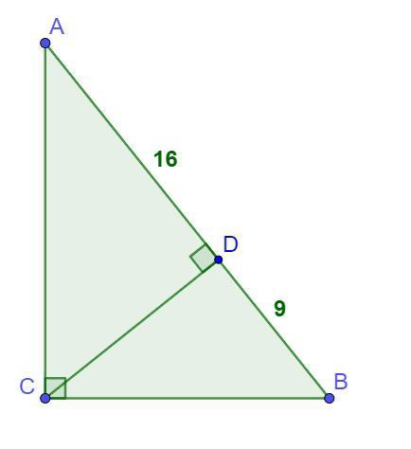
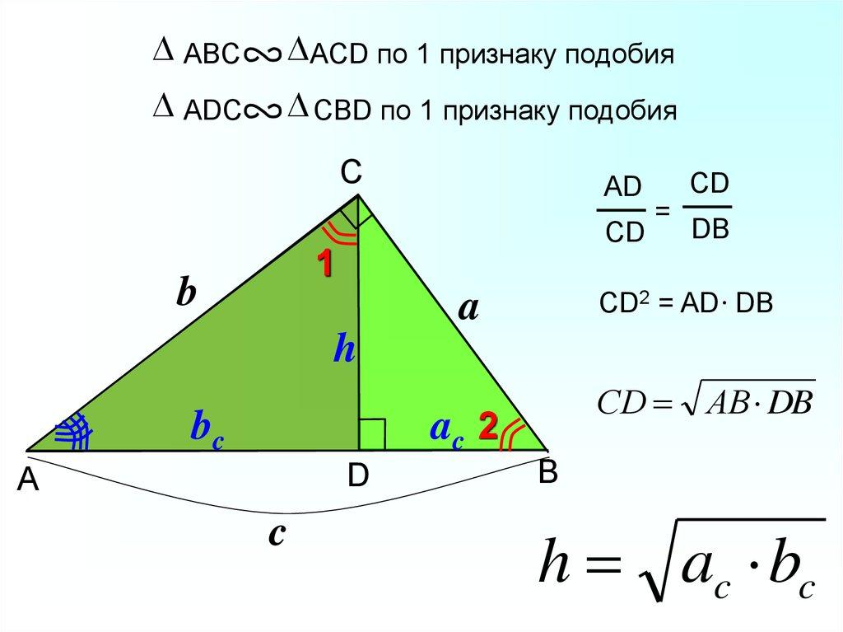
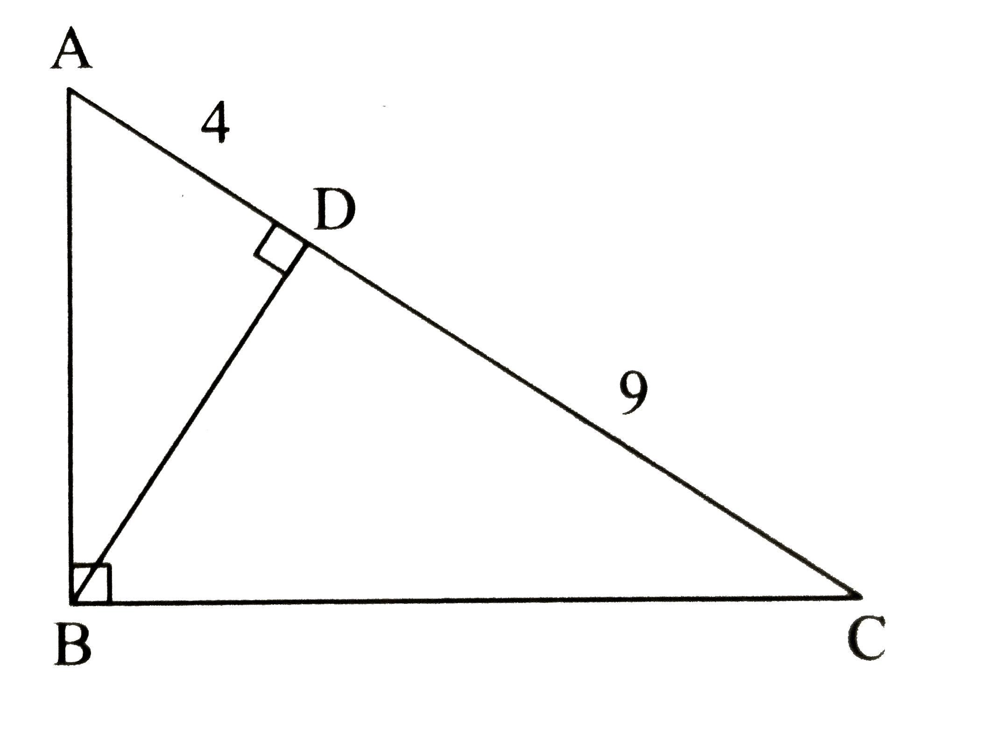

First Euclid's Theorem — Altitude Theorem
# Source: AI Source: Provided by: [Data Path: Persons Table -> ID Column: 1, Name_En Column: Motasem Essam] -> From: [ChatGPT] on [7/25/2026]
The First Euclid's Theorem states that the altitude to the hypotenuse is the geometric mean of the two segments of the hypotenuse.
If:
$$CD⊥AB$$
then:
$$\boxed{CD^{2}=AD⋅DB}$$
Using:
$$CD=h, AD=p, DB=q$$
we obtain:
$$\boxed{h^{2}=pq}$$
Therefore:
$$\boxed{h=\sqrt{pq}}$$

Example 1 — Finding the Altitude
# Source: AI Source: Provided by: [Data Path: Persons Table -> ID Column: 1, Name_En Column: Motasem Essam] -> From: [ChatGPT] on [7/25/2026]
Suppose:
$$AD=4$$
and:
$$DB=9$$
Then:
$$h^{2}=4\left(9\right) \\ h^{2}=36$$
Therefore:
$$\boxed{h=6}$$
So the altitude to the hypotenuse is $6$.
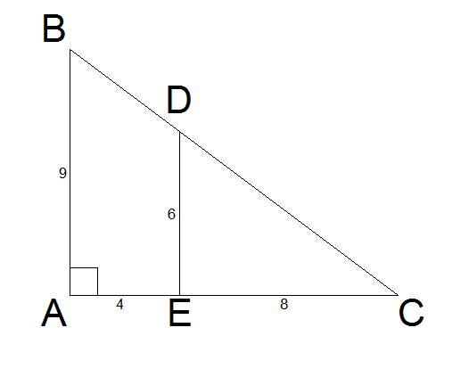
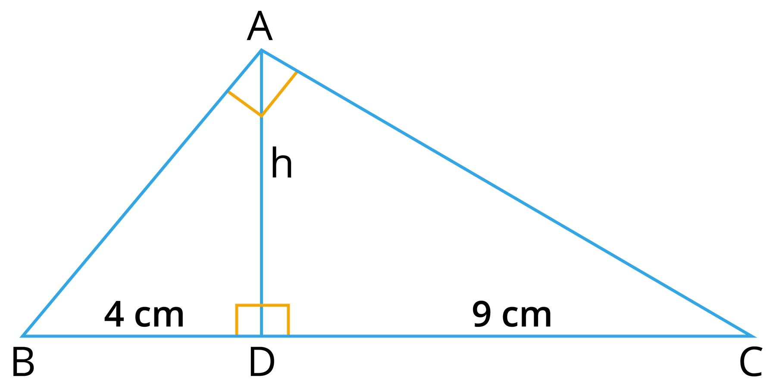
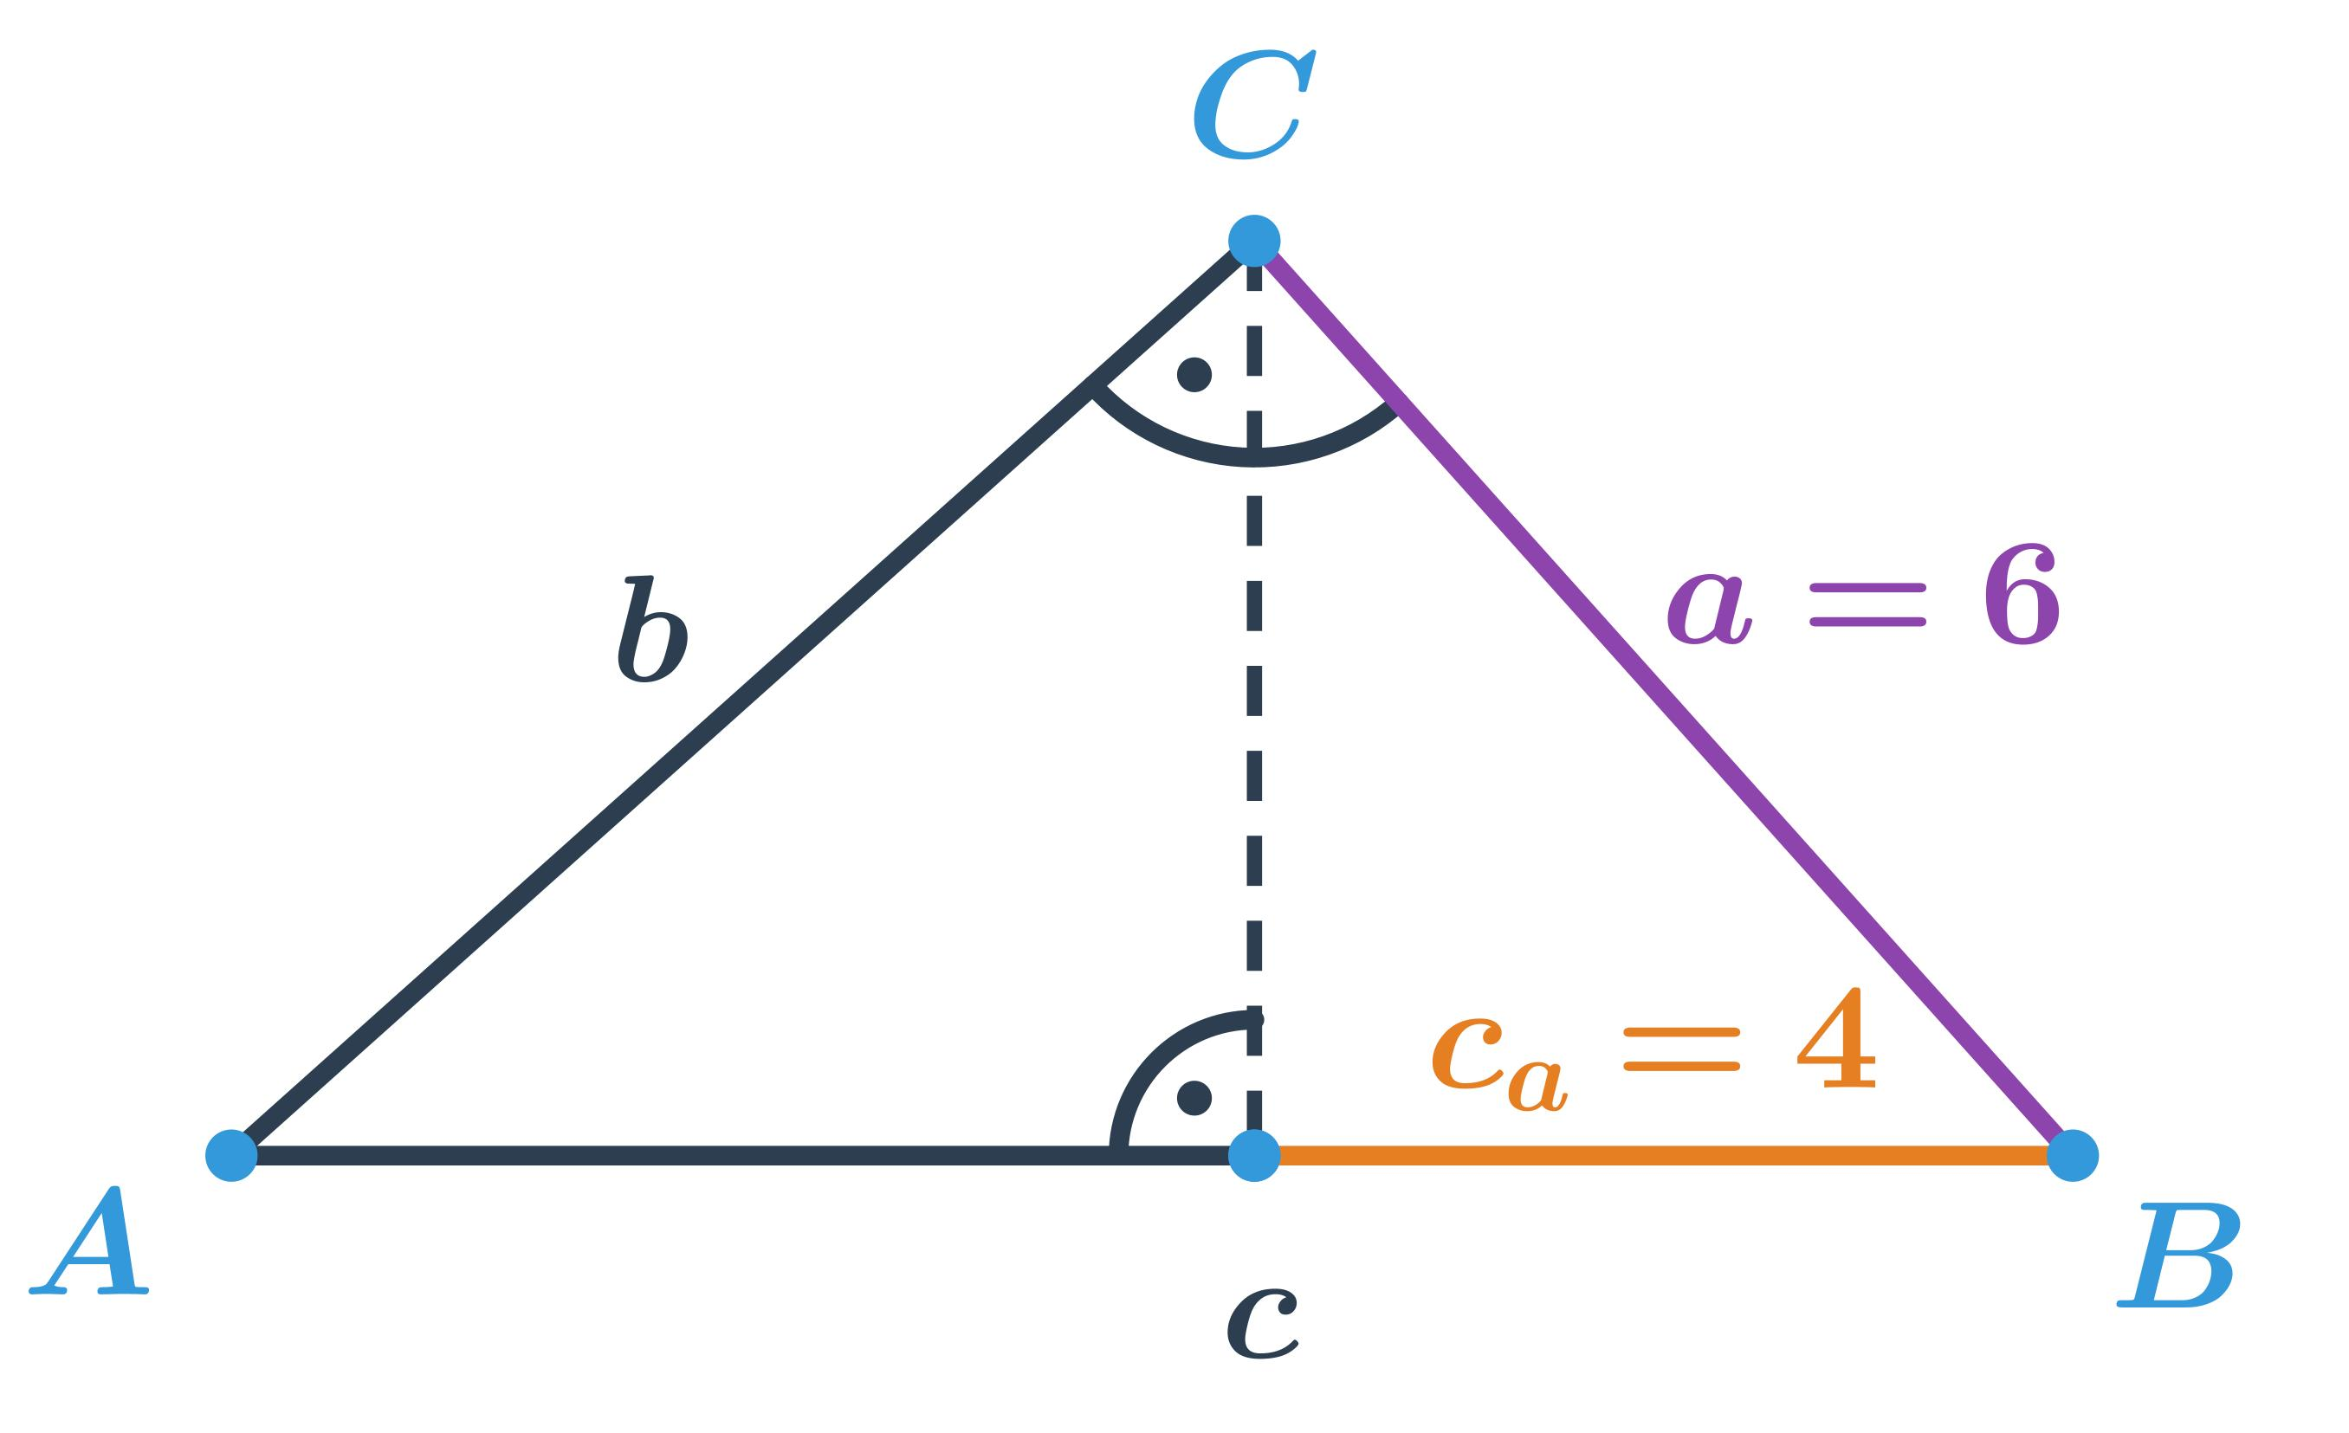
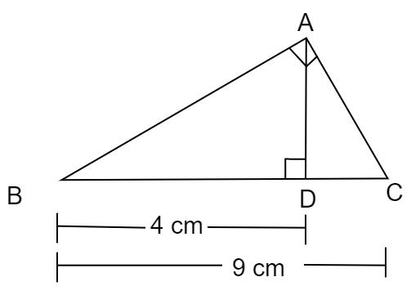
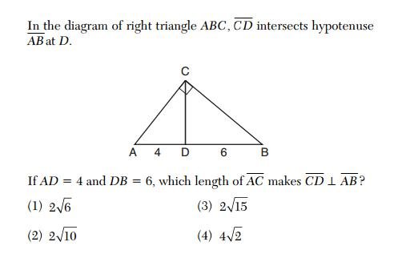

Second Euclid's Theorem — Leg Theorem
# Source: AI Source: Provided by: [Data Path: Persons Table -> ID Column: 1, Name_En Column: Motasem Essam] -> From: [ChatGPT] on [7/25/2026]
The Second Euclid's Theorem states that the square of a leg of a right triangle equals the product of the hypotenuse and the hypotenuse segment adjacent to that leg.
For leg $AC$:
$$\boxed{AC^{2}=AB⋅AD}$$
For leg $BC$:
$$\boxed{BC^{2}=AB⋅DB}$$
Using:
$$AB=c, AD=p, DB=q$$
we get:
$$\boxed{AC^{2}=cp}$$
and:
$$\boxed{BC^{2}=cq}$$
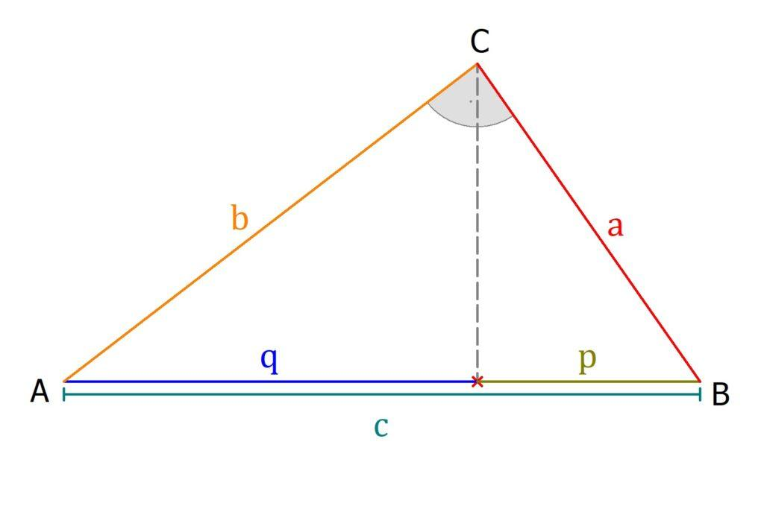
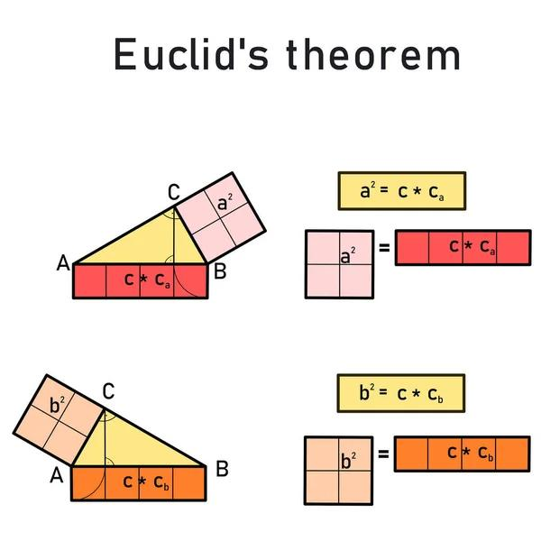
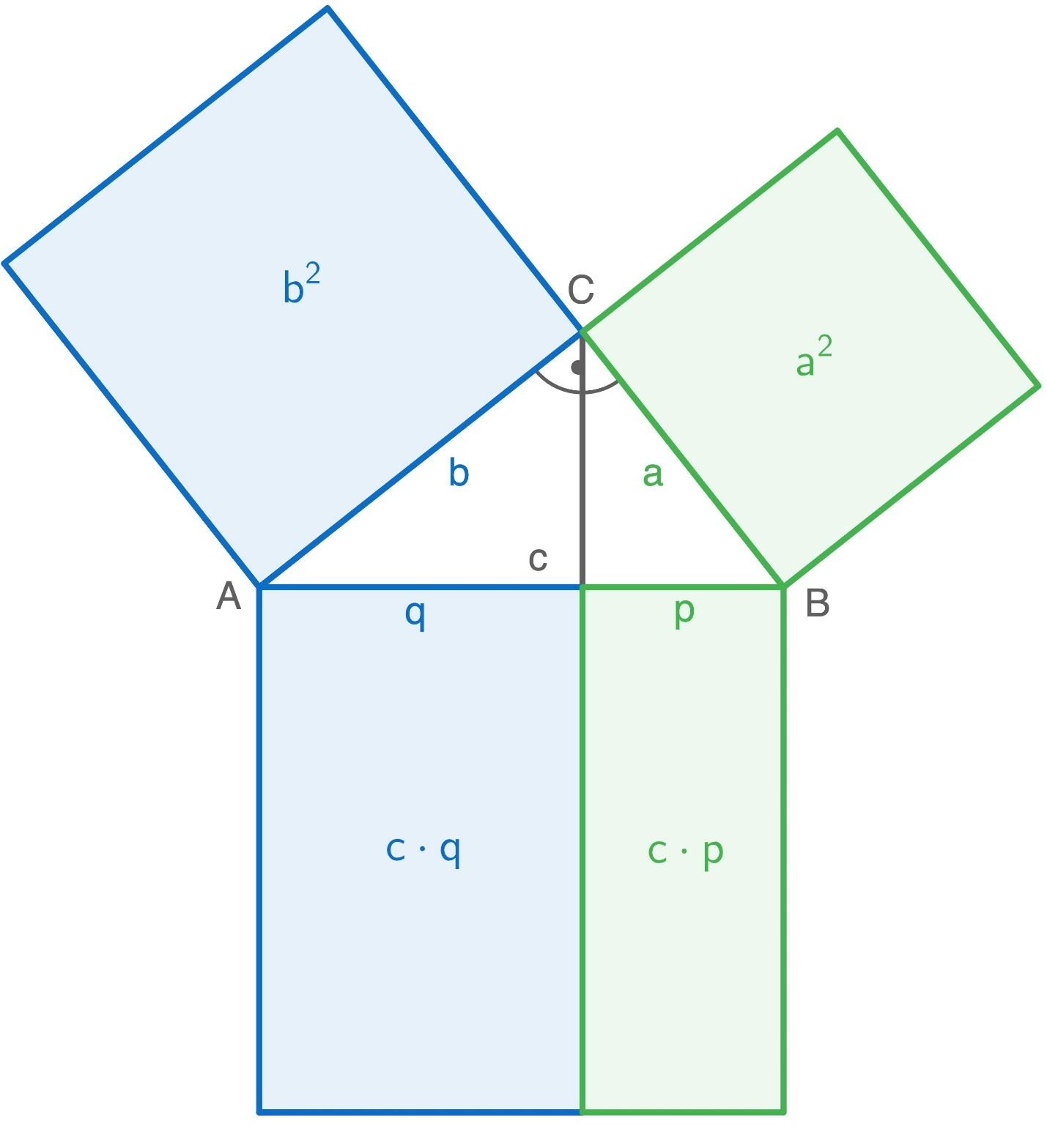
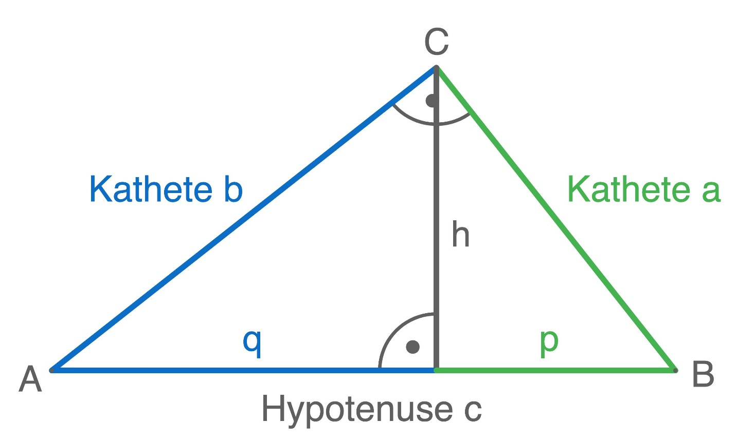

Geometric Mean Interpretation
# Source: AI Source: Provided by: [Data Path: Persons Table -> ID Column: 1, Name_En Column: Motasem Essam] -> From: [ChatGPT] on [7/25/2026]
Euclid's Theorems are based on geometric means.
The first theorem:
$$h^{2}=pq$$
means:
$$\boxed{h=\sqrt{pq}}$$
Therefore, $h$ is the geometric mean of $p$ and $q$.
Similarly:
$$AC^{2}=cp$$
means:
$$\boxed{AC=\sqrt{cp}}$$
and:
$$BC^{2}=cq$$
means:
$$\boxed{BC=\sqrt{cq}}$$

Similar Triangles Behind the Theorems
# Source: AI Source: Provided by: [Data Path: Persons Table -> ID Column: 1, Name_En Column: Motasem Essam] -> From: [ChatGPT] on [7/25/2026]
Drawing the altitude creates three similar triangles:
$$\boxed{△ACD∼△CBD∼△ABC}$$
This similarity produces the proportional relationships used in Euclid's Theorems.
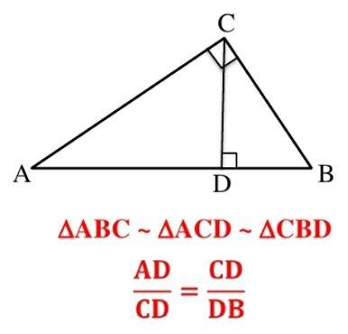
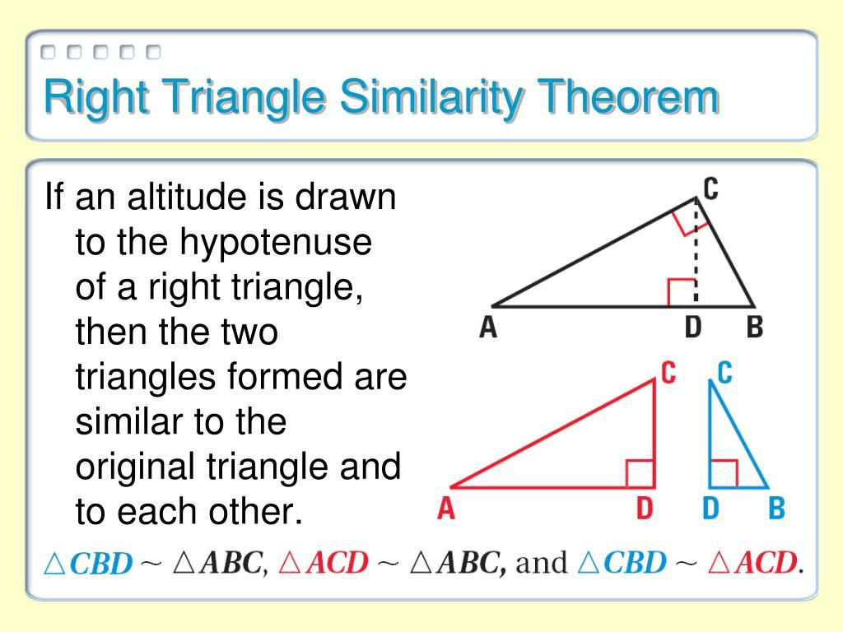
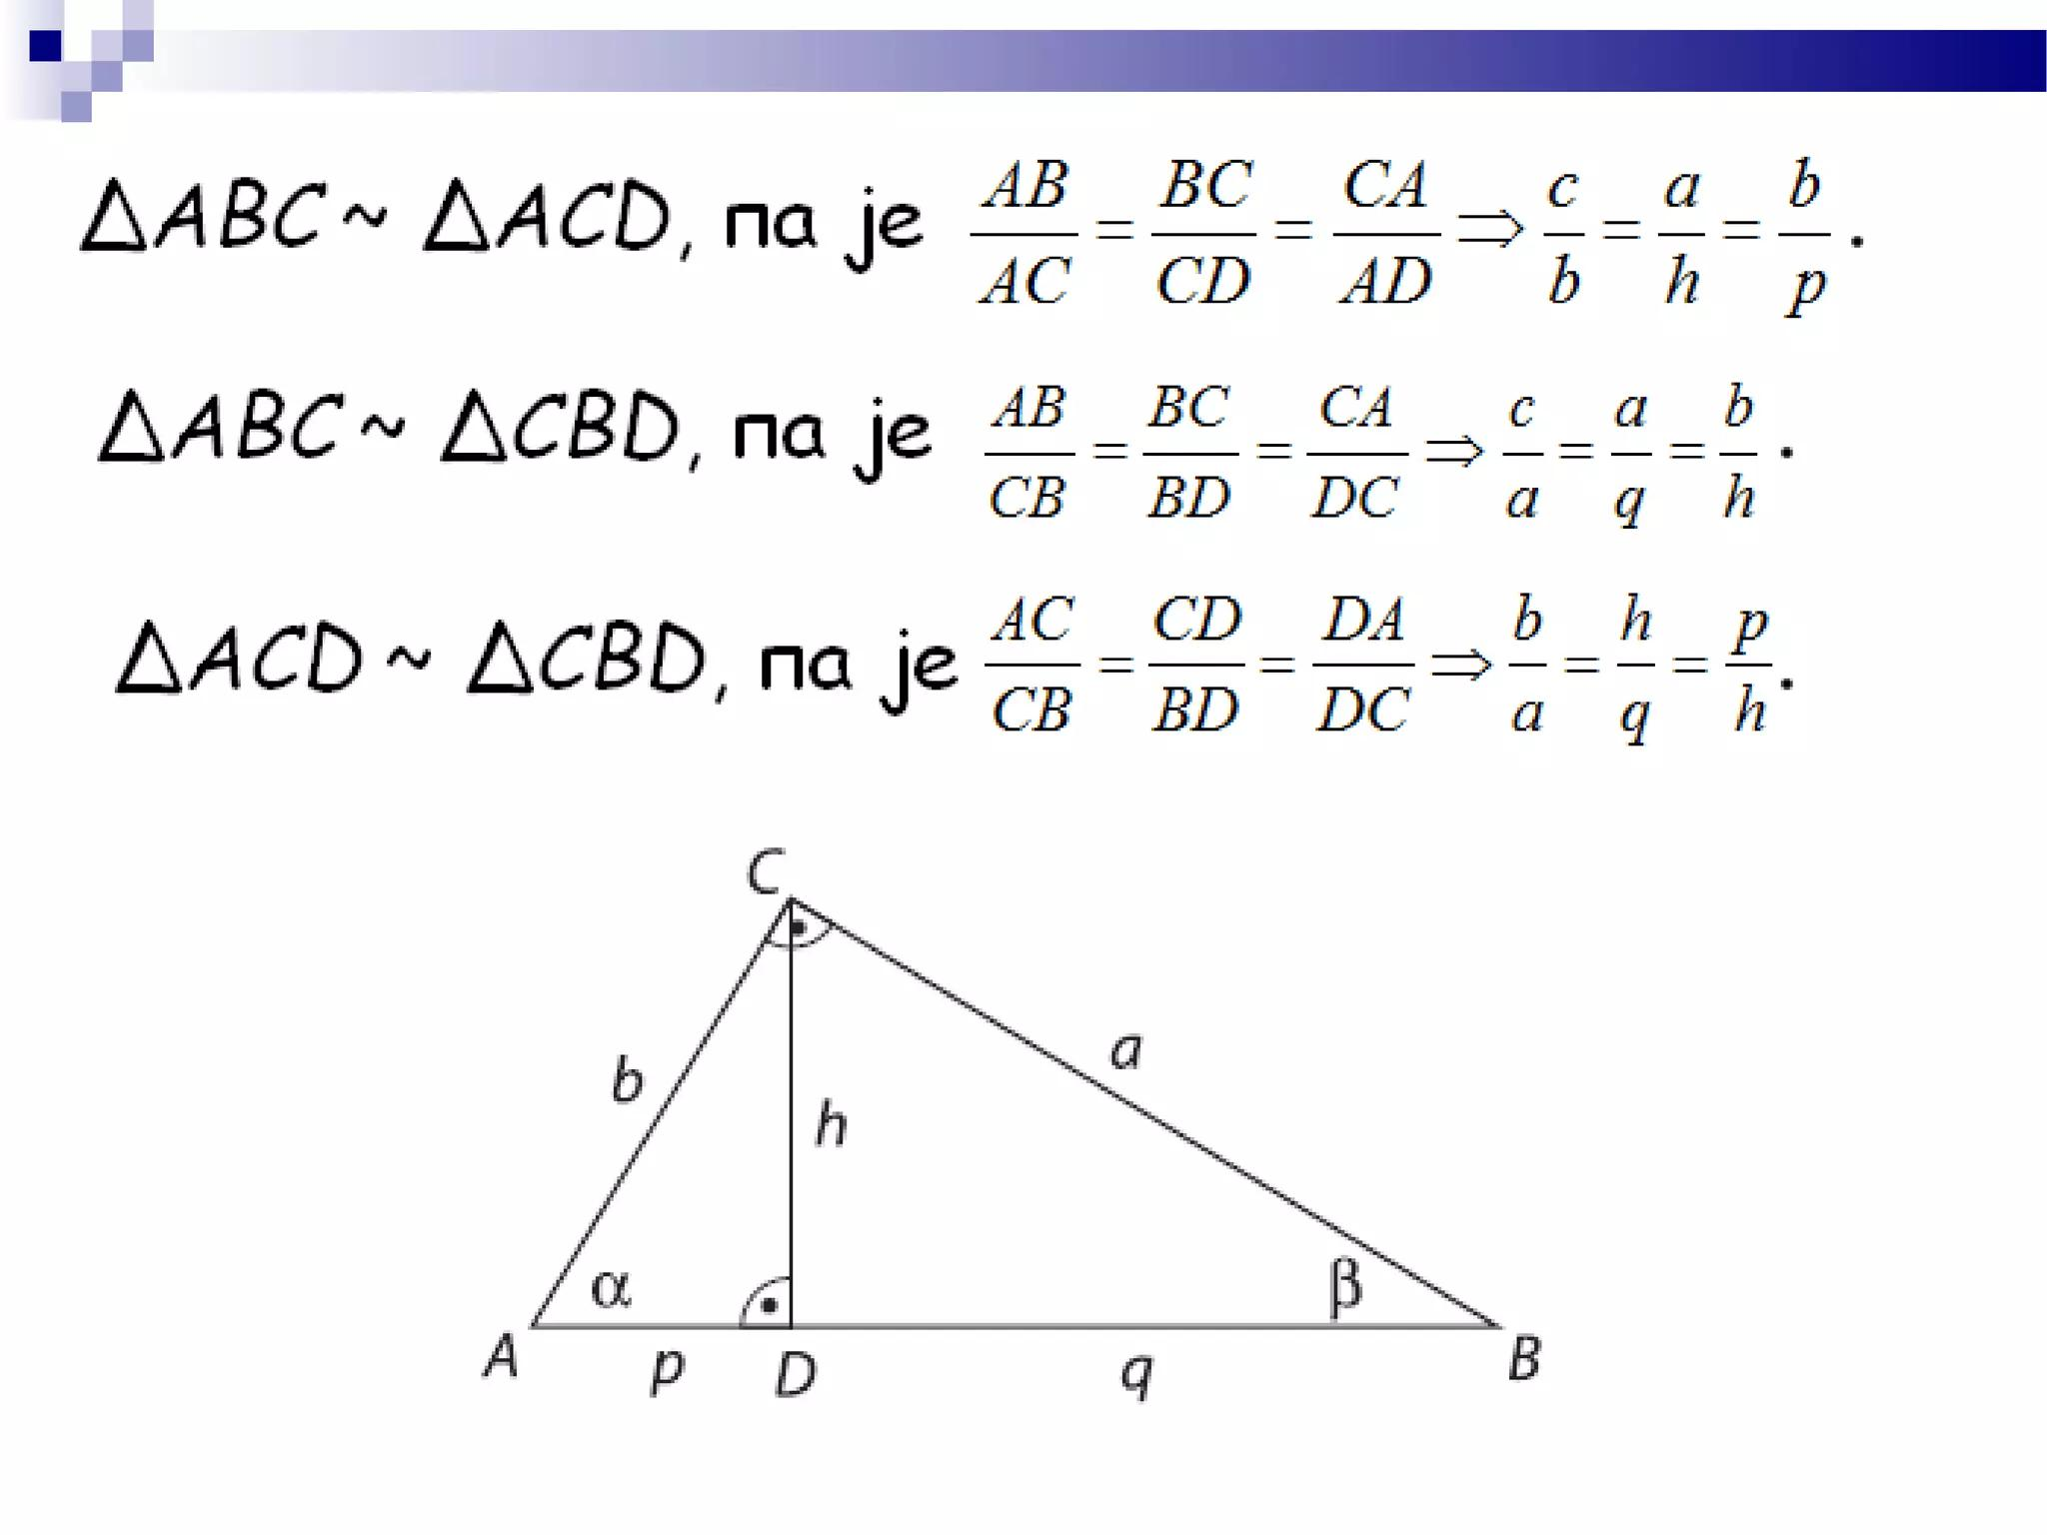
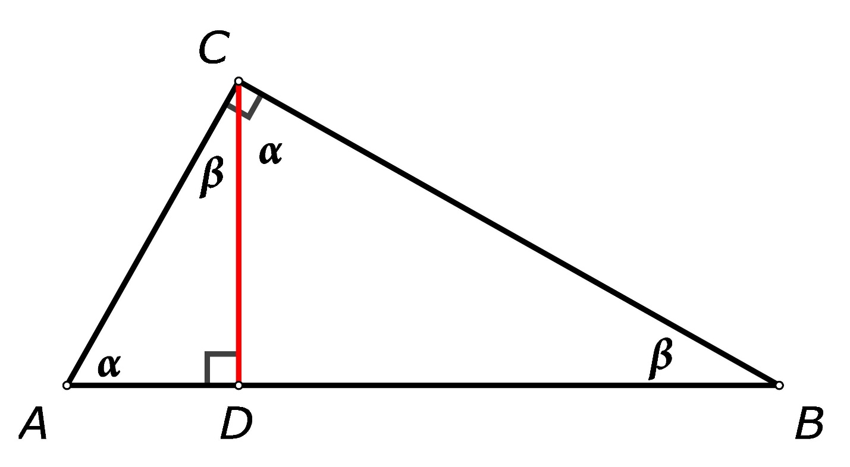

Derivation of the First Theorem
# Source: AI Source: Provided by: [Data Path: Persons Table -> ID Column: 1, Name_En Column: Motasem Essam] -> From: [ChatGPT] on [7/25/2026]
From the similarity of the smaller triangles:
$$△ACD∼△CBD$$
we obtain:
$$\frac{AD}{CD}=\frac{CD}{DB}$$
Cross-multiplying:
$$CD^{2}=AD⋅DB$$
Therefore:
$$\boxed{h^{2}=pq}$$

Derivation of the Second Theorem
# Source: AI Source: Provided by: [Data Path: Persons Table -> ID Column: 1, Name_En Column: Motasem Essam] -> From: [ChatGPT] on [7/25/2026]
From:
$$△ACD∼△ABC$$
we obtain:
$$\frac{AC}{AB}=\frac{AD}{AC}$$
Cross-multiplying:
$$AC^{2}=AB⋅AD$$
Therefore:
$$\boxed{AC^{2}=cp}$$
Similarly:
$$\boxed{BC^{2}=cq}$$

Example 2 — Finding a Leg
# Source: AI Source: Provided by: [Data Path: Persons Table -> ID Column: 1, Name_En Column: Motasem Essam] -> From: [ChatGPT] on [7/25/2026]
Suppose:
$$AB=25$$
and:
$$AD=9$$
Find $AC$.
Using:
$$AC^{2}=AB⋅AD$$
we get:
$$AC^{2}=25\left(9\right) \\ AC^{2}=225$$
Therefore:
$$\boxed{AC=15}$$

Example 3 — Finding the Other Leg
# Source: AI Source: Provided by: [Data Path: Persons Table -> ID Column: 1, Name_En Column: Motasem Essam] -> From: [ChatGPT] on [7/25/2026]
Suppose:
$$AB=25$$
and:
$$DB=16$$
Then:
$$BC^{2}=AB⋅DB \\ BC^{2}=25\left(16\right) \\ BC^{2}=400$$
Therefore:
$$\boxed{BC=20}$$
This produces the familiar $15$-$20$-$25$ right triangle.

Relationship with the Pythagorean Theorem
# Source: AI Source: Provided by: [Data Path: Persons Table -> ID Column: 1, Name_En Column: Motasem Essam] -> From: [ChatGPT] on [7/25/2026]
Euclid's Theorems are closely related to the Pythagorean Theorem.
Suppose:
$$AC^{2}=cp$$
and:
$$BC^{2}=cq$$
Adding them:
$$AC^{2}+BC^{2}=cp+cq$$
Factor:
$$AC^{2}+BC^{2}=c\left(p+q\right)$$
Since:
$$p+q=c$$
we get:
$$AC^{2}+BC^{2}=c^{2}$$
Therefore:
$$\boxed{a^{2}+b^{2}=c^{2}}$$
So the Pythagorean Theorem can be derived from Euclid's relationships.

Euclid's Theorems vs Pythagorean Theorem
# Source: AI Source: Provided by: [Data Path: Persons Table -> ID Column: 1, Name_En Column: Motasem Essam] -> From: [ChatGPT] on [7/25/2026]
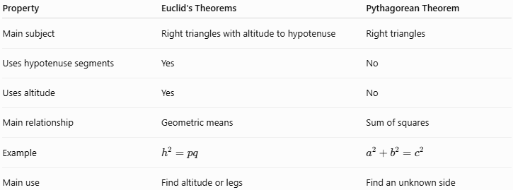
Property | Euclid's Theorems | Pythagorean Theorem
Main subject | Right triangles with altitude to hypotenuse | Right triangles
Uses hypotenuse segments | Yes | No
Uses altitude | Yes | No
Main relationship | Geometric means | Sum of squares
Example | $$h^{2}=pq$$ | $$a^{2}+b^{2}=c^{2}$$
Main use | Find altitude or legs | Find an unknown side

Important Formulas
# Source: AI Source: Provided by: [Data Path: Persons Table -> ID Column: 1, Name_En Column: Motasem Essam] -> From: [ChatGPT] on [7/25/2026]
For a right triangle with:
$$c=\text{hypotenuse} \\ p,q=\text{hypotenuse segments} \\ h=\text{altitude}$$
the main formulas are:
First Euclid's Theorem
$$\boxed{h^{2}=pq}$$
or:
$$\boxed{h=\sqrt{pq}}$$
Second Euclid's Theorem
$$\boxed{a^{2}=cp} \\ \boxed{b^{2}=cq}$$
or:
$$\boxed{a=\sqrt{cp}} \\ \boxed{b=\sqrt{cq}}$$
Hypotenuse
$$\boxed{c=p+q}$$

Complete Relationship Diagram
# Source: AI Source: Provided by: [Data Path: Persons Table -> ID Column: 1, Name_En Column: Motasem Essam] -> From: [ChatGPT] on [7/25/2026]
The relationships can be summarized as:
$$\boxed{\begin{aligned}h^{2}&=pq \\ a^{2}&=cp \\ b^{2}&=cq \\ c&=p+q\end{aligned}}$$
where:
- $a,b$ = legs
- $c$ = hypotenuse
- $h$ = altitude to the hypotenuse
- $p,q$ = two segments of the hypotenuse

Special Example — $3$-$4$-$5$ Triangle
# Source: AI Source: Provided by: [Data Path: Persons Table -> ID Column: 1, Name_En Column: Motasem Essam] -> From: [ChatGPT] on [7/25/2026]
Consider a right triangle with:
$$a=3, b=4, c=5$$
The altitude to the hypotenuse is:
$$h=\frac{ab}{c}$$
Therefore:
$$h=\frac{3\left(4\right)}{5} \\ \boxed{h=\frac{12}{5}=2.4}$$
The hypotenuse segments are:
$$p=\frac{a^{2}}{c}=\frac{9}{5}$$
and:
$$q=\frac{b^{2}}{c}=\frac{16}{5}$$
Check the first Euclid theorem:
$$h^{2}=pq \\ {\left(2.4\right)}^{2}=\frac{9}{5}⋅\frac{16}{5} \\ 5.76=5.76$$
Therefore, the relationship holds.

Real-World Applications
# Source: AI Source: Provided by: [Data Path: Persons Table -> ID Column: 1, Name_En Column: Motasem Essam] -> From: [ChatGPT] on [7/25/2026]
Euclid's Theorems can be applied in:
- Architecture.
- Construction.
- Engineering.
- Surveying.
- Structural design.
- CAD.
- Computer graphics.
- Land measurement.
- Technical drawing.
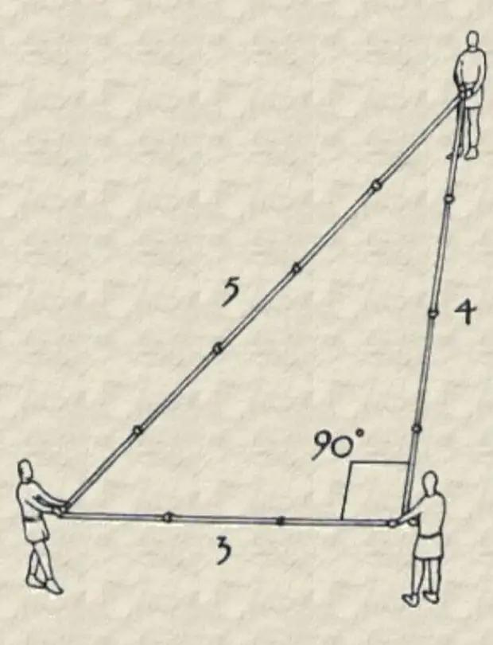
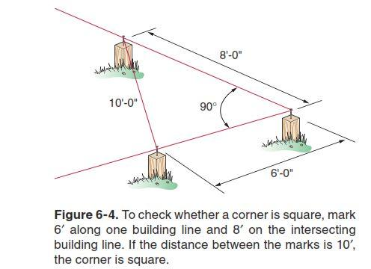
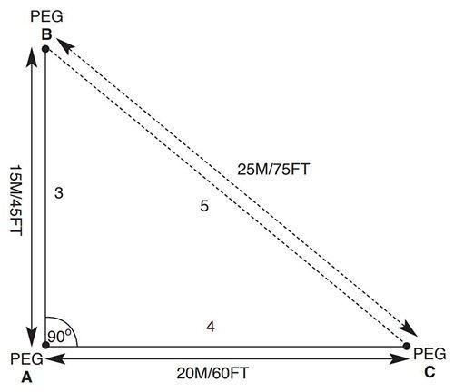
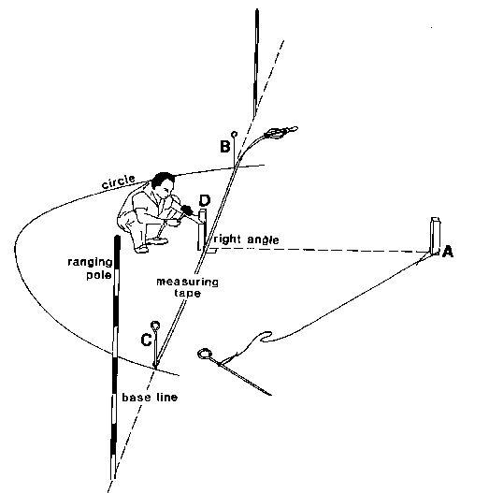
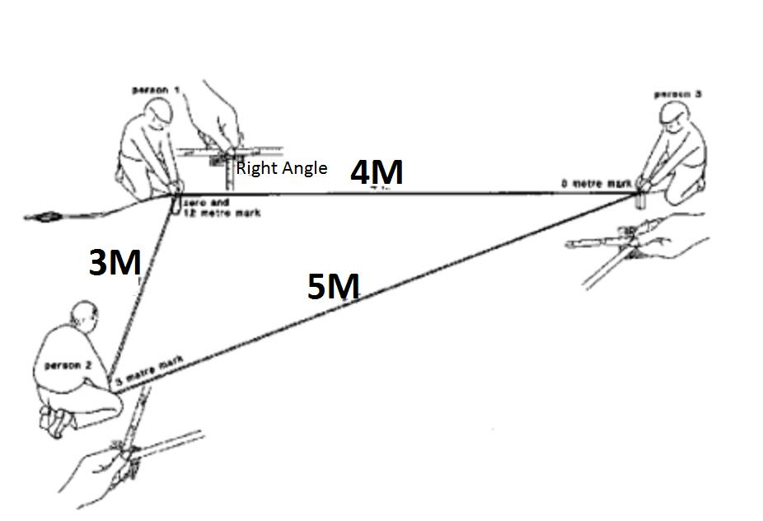

Applications
# Source: AI Source: Provided by: [Data Path: Persons Table -> ID Column: 1, Name_En Column: Motasem Essam] -> From: [ChatGPT] on [7/25/2026]
Euclid's Theorems are important in:
- Plane Geometry
- Right Triangle Geometry
- Euclidean Geometry
- Similar Triangles
- Proportionality
- Trigonometry
- Engineering
- Architecture
- Surveying
- CAD
- Structural Analysis

Advantages
# Source: AI Source: Provided by: [Data Path: Persons Table -> ID Column: 1, Name_En Column: Motasem Essam] -> From: [ChatGPT] on [7/25/2026]
Studying Euclid's Theorems helps to:
- Find unknown lengths in right triangles.
- Understand geometric means.
- Apply triangle similarity.
- Connect proportionality with geometry.
- Provide alternative methods for solving right-triangle problems.
- Understand the relationship between Euclid's Theorems and the Pythagorean Theorem.

Limitations
# Source: AI Source: Provided by: [Data Path: Persons Table -> ID Column: 1, Name_En Column: Motasem Essam] -> From: [ChatGPT] on [7/25/2026]
Euclid's Theorems:
- Apply specifically to right-triangle configurations.
- Require an altitude drawn from the right-angle vertex to the hypotenuse.
- Require correct identification of the hypotenuse segments.
- Are not directly applicable to arbitrary non-right triangles.
- Depend on proportional relationships created by similar triangles.

Comparison with Related Concepts
# Source: AI Source: Provided by: [Data Path: Persons Table -> ID Column: 1, Name_En Column: Motasem Essam] -> From: [ChatGPT] on [7/25/2026]
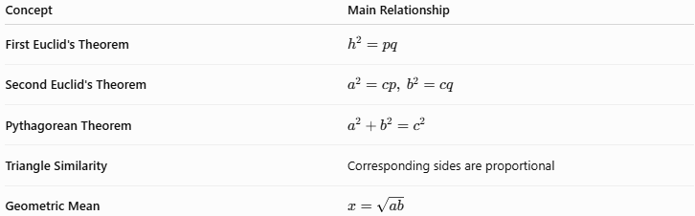
Concept | Main Relationship
First Euclid's Theorem | $$h^{2}=pq$$
Second Euclid's Theorem | $$a^{2}=cp, b^{2}=cq$$
Pythagorean Theorem | $$a^{2}+b^{2}=c^{2}$$
Triangle Similarity | Corresponding sides are proportional
Geometric Mean | $$x=\sqrt{ab}$$

Key Points
# Source: AI Source: Provided by: [Data Path: Persons Table -> ID Column: 1, Name_En Column: Motasem Essam] -> From: [ChatGPT] on [7/25/2026]
- Euclid's Theorems apply to right triangles.
- An altitude is drawn from the right angle to the hypotenuse.
- The altitude divides the hypotenuse into two segments.
- The First Euclid's Theorem states:
$$\boxed{h^{2}=pq}$$
- The Second Euclid's Theorem states:
$$\boxed{a^{2}=cp}$$
and:
$$\boxed{b^{2}=cq}$$
- These relationships come from similar triangles.
- The altitude is the geometric mean of the two hypotenuse segments.
- Each leg is the geometric mean of the hypotenuse and its adjacent hypotenuse segment.
- Euclid's Theorems are closely connected to the Pythagorean Theorem.

Conclusion
# Source: AI Source: Provided by: [Data Path: Persons Table -> ID Column: 1, Name_En Column: Motasem Essam] -> From: [ChatGPT] on [7/25/2026]
Euclid's Theorems in Right Triangles describe important proportional relationships created when an altitude is drawn from the right-angle vertex to the hypotenuse. The first theorem relates the altitude to the two segments of the hypotenuse:
$$\boxed{h^{2}=pq}$$
while the second theorem relates each leg to the hypotenuse and its adjacent segment:
$$\boxed{a^{2}=cp, b^{2}=cq}$$
These theorems are consequences of similar triangles and the concept of the geometric mean. They provide powerful methods for calculating unknown lengths and form an important connection between similarity, proportionality, and the Pythagorean Theorem.

